**Leader Overview**

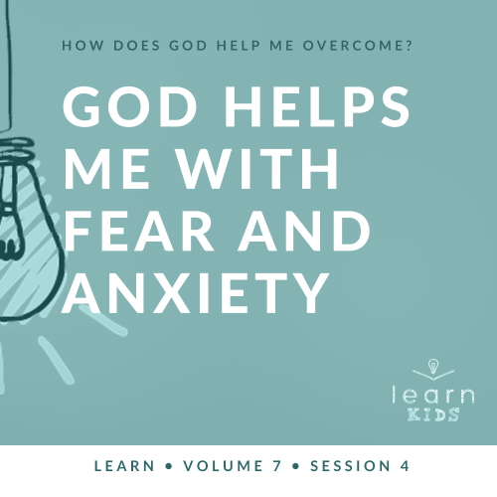

**Volume Overview**

**How does God help me overcome?**

*Life can be full of challenges. Thankfully, when we make the decision to live for God, we can have confidence that we’re no longer walking through life alone. God offers His help to us throughout every difficult circumstance. He knows that we’ll face fears, decisions, and emotions that we don’t feel equipped to handle. When we don’t know what to do, we can turn to God for the answer. He will help us overcome every challenge.*

**Session Overview**

**God Helps Me with Fear and Anxiety**

*We all face different kinds of fear in life. As Christians, we can know that God is with us. He is greater than anything we might have to face. We can trust God with those fears, and we can respond with faith, knowing that God will help us. In our Bible story, Jacob faces the fear of losing another son and having to move to a faraway land. He chooses to overcome his fear by acting with faith.*

**Bible Lesson**

Jacob Overcomes Fear

[Genesis 42:1–4](https://ref.ly/logosref/Bible.Ge42.1-4); [45:16–18](https://ref.ly/logosref/Bible.Ge45.16-18); [46:1–5](https://ref.ly/logosref/Bible.Ge46.1-5)

**Faith Fact**

God helps me when I am afraid.

**Faith Verse**

[Philippians 4:13](https://ref.ly/logosref/Bible.Php4.13) (NLT)

For I can do everything through Christ, who gives me strength.

**Preparing for the Session**

**Leader Preparation Time: 20–25 Minutes**

|  |
| --- |
| ***You Will Need***  ***Large Group***   * *Bible* * *Worship songs (Song suggestions: “Nothing Is Impossible” by Planetshakers; “Won’t Let Go” by Gateway Kids Worship; “Overcome” by Elevation Worship; “Holy Ground” by Passion)* * *For groups not using a phone or tablet only, add:*   *• Projector or TV*  *• Laptop*  *•* ***Faith Fact Slide***  *•* ***Faith Verse Video*** *or* ***Slide***  *•* ***Bible Lesson Video***  *•* ***Teaching Point Slides 1–3***  *• Coin*  *• One heavy object, too heavy for one kid to lift but movable for a group*  *• Paper strips, one per kid*  *• Pencils or pens, one per kid*  *• Basket or box*  *• Ball*  ***Small Group***   * ***Small Group Group Connection Page*** * *Bibles for kids in your group to share* * ***Small Group Activity Page****, one per kid* * ***Activity Page Answer Page*** * *Pens or pencils, one per kid.*   *To access session content and videos from a computer, visit:* [*BibleEngagementProject.com/downloads*](https://bibleengagementproject.com/downloads) |
| ***Getting Ready***  ***Large Group***   * *Download videos and slides if needed.* * *Select worship song(s) and have them ready to play.* * *Read the Bible Lesson Scripture to prepare for Teaching Time.*   ***Small Group***   * *Print the* ***Small Group Group Connection Page****, one per group.* * *Print copies of the* ***Small Group Activity Page****, one per kid.* * *Print one* ***Activity Page Answer Page*** *to show the answer to the maze.*   *First time leading* Learn *for Kids? Check out the* [*Facilitator Guide*](https://0b769b0ed3569ef9d18b-f88d8272f61086866d50d048b43ef630.ssl.cf2.rackcdn.com/sites/biblengagementproject/Listen_Facilitator_Guide.pdf)*.* |

**Large Group**

**30 Minutes**

*See what’s needed at the beginning of the session.*

**Introduction**

Hello, everyone! I’m so excited that you’re here. Today, we’ll learn that God helps us with fear and anxiety. There are many times in our life when we may feel anxious, afraid, or worried. Sometimes the fear comes from things we’ll face our whole life like spiders or terrible storms. At other times, the worry might come from a temporary situation like taking a big test or going to a new school.

• *Insert a personal story about something you’re afraid of. Try to keep it light and not too scary if possible.*

• *If you can’t think of a personal story immediately, tell a story about a boy who was afraid of storms because thunder is so loud. The kid prayed and asked God to help him not be afraid. Then, he fell asleep.*

Do you have anything you’re afraid of that you’re willing to tell us about? *(Allow responses.)* Those are some challenging fears.

**Faith Fact**

Everyone is afraid of something. But God can help us work through our fears and worries no matter what they are. Our Faith Fact today is **God helps me when I am afraid**.

• *Show the* ***Faith Fact Slide.***

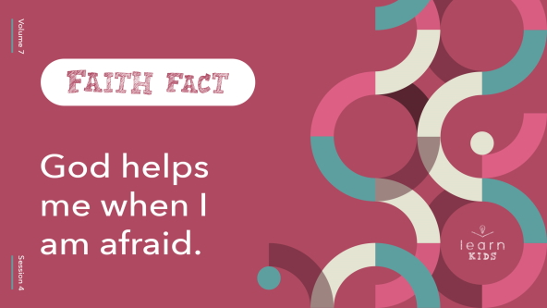

This Faith Fact is very important for all of us to remember. Everyone, show me your best scared face. *(Group response)* Let’s say the Faith Fact together, sounding as scared as we can. **God helps me when I am afraid.** Now, show me your brave face. *(Group response)* This time sound brave and courageous as we say it. **God helps me when I am afraid.** Great job!

**Game**

**Heads or Tails**

|  |
| --- |
| ***You Will Need***   * *Coin*   *No prep needed for this activity.* |

Sometimes in life we can wonder about what’s going to happen, but we can’t control everything. That’s like the game we’ll play called Heads or Tails. Here’s how it works. Before I flip the coin, everyone in the room will guess if the coin will land heads up or tails up. If you think it will be heads, then place your hands on your head. If you think tails, then place your hands by your sides. If you guess right, you get to keep playing. If you guess wrong, you’ll have to sit down. Everyone, stand up, and let’s play.

• *Repeat flipping the coin until someone wins.*

• *Play again if time allows.*

Great job! You know, this game is a little like life. Sometimes we can guess what will happen. But other times bad things can happen that we never could have guessed. We might get scared or worried about what might happen. Thankfully, we can trust that no matter what happens, God is ready to help us through it all.

**Worship**

One way that we can be reminded of how God helps us work through our fears and worries is through worship. Who is ready to worship God today? *(Group response)* One way to worship God is by singing. Let’s worship Him by singing together.

• *Lead the kids in singing one or two praise songs. See suggestions at the beginning of the session.*

**Bible Lesson**

That was an incredible time of worshipping God together! I’m so thankful that God’s presence can help to calm our fears and worries. Let’s find out what God’s Word has to say about that.

Today, we’ll hear about a man named Jacob. He was the father of Joseph and all his brothers. Did Joseph’s dad know he was alive? *(Group response)* At this point in Joseph’s story, his dad didn’t know that he was alive. Not only was Joseph alive but God also helped him get out of prison and become a very important leader in Egypt. God would also bring Joseph and Jacob back together again. Today, we’ll hear more about that.

**Prayer**

|  |
| --- |
| *Dear God, help us to learn from Your Word today. Help us to see how You help us work through our fears. Help us learn what we can do to trust You with them. Amen.* |

**Video Intro**

Just before we look at the Bible story, let’s watch this video.

• *Play* ***Bible Lesson Video****.*

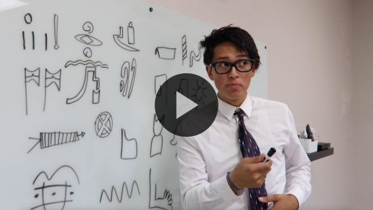

**Bible Story**

**Jacob Overcomes Fear**

That video was such a fun lead-in to our Bible story today! Earlier, we talked about some fears that we have. Why do you think certain things make us afraid? *(Allow responses.)* Those are some pretty good reasons. We might be afraid of something because we don’t fully understand what’s going on. Sometimes we’re afraid because it’s connected to something that caused us pain in the past. For example, if an angry dog bit you when you were younger, do you think it would be easy to be near a big dog now? *(Group response)*

Let’s read about Joseph’s father, Jacob, who was afraid for both of those reasons. Grab your Bible or pull up a Bible app on your device. Turn to [Genesis 42:1–4](https://ref.ly/logosref/Bible.Ge42.1-4).

• *Read* [*Genesis 42:1–4*](https://ref.ly/logosref/Bible.Ge42.1-4)*;* [*45:3–9*](https://ref.ly/logosref/Bible.Ge45.3-9)*,* [*16–18*](https://ref.ly/logosref/Bible.Ge45.16-18)*;* [*46:1–5*](https://ref.ly/logosref/Bible.Ge46.1-5) *aloud to the group.*

• *In order to keep Large Group time moving along, we don’t recommend having the kids read.*

• *Optional: Remind the kids to mark this place with their Bible Bookmark, so they can read it on their own at home.*

**Teaching Time**

|  |
| --- |
| ***You Will Need***   * ***Teaching Point Slides 1–3*** * *One heavy object, too heavy for one kid to lift but movable for a group*   *No prep needed for this activity.* |

Jacob had some difficult things to face, didn’t he? *(Group response)* First Jacob sent his older sons to get food in Egypt. They didn’t realize that they had bowed down to Joseph when they were there. Remember Joseph’s dream about that? *(Group response)* Later, Jacob had to send his sons back to Egypt for more food. This time he had to send his youngest son, Benjamin. Jacob didn’t want to let Benjamin go because he was afraid of what had happened to Joseph earlier. Jacob didn’t want to lose another son. He had to trust God with his fears.

Then, the most amazing thing happened! Joseph’s brothers found out that he was alive and was now a leader in Egypt. Because of the famine, Joseph invited his whole family to move there. Even the Pharaoh was ready to help Jacob’s family.

The good news was Jacob found out Joseph was alive. The bad news was that he had to travel a long way to see him again. Seeing how God helped Jacob can teach us a lot about how God can help us. That’s why our Faith Fact is so important. Say it with me. **God helps me when I am afraid**. Shout it this time. **God helps me when I am afraid**. Here are three things we need to know whenever we’re feeling afraid.

**1. We all face different kinds of fears.**

• *Show the* ***Teaching Point 1 Slide.***

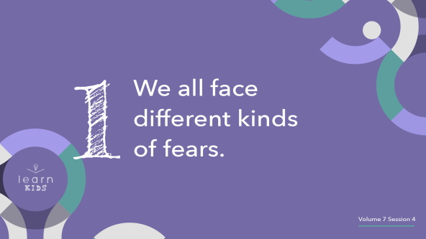

We talked about things we’re afraid of earlier, but did you know there are scientific names for certain kinds of fears? *(Group response)* Those fears are called *phobias*. A phobia is something you’re intensely afraid of. For example, the fear of spiders is called arachnophobia. Raise your hand if you’re at least a little afraid of spiders. *(Group response)* That’s pretty common. A lot of people are afraid of spiders. A fear of heights is acrophobia, which is also pretty common. Then, there are some unusual fears. Did you know there’s a phobia of peanut butter sticking to the roof of your mouth? That’s very specific, right? People even have phobias about the color yellow and the number eight. Raise your hand if you’ve got either of those fears. *(Group response)*

Now, it’s not wrong to be afraid of something. Everyone has fears for a different reason, even unusual ones like colors and numbers. We all face different kinds of fears. Some of them are small and some are big. What I want you to understand is that you aren’t the only one with fears. Some people aren’t afraid of what we fear, and we aren’t always afraid of what other people fear. Fear is different from person to person. It can be really hard to trust God with our fears.

**2. We can trust God with our fears.**

• *Show the* ***Teaching Point 2 Slide.***

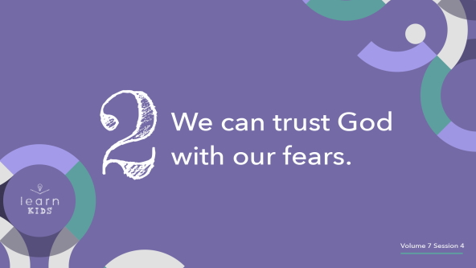

I have this very heavy object I need someone to carry. Let’s see who wants to volunteer to pick this up for me. *(Group response)*

• *Invite a small kid to try and carry the object. They shouldn’t be able to, or if they are, they shouldn’t be able to hold it long.*

Oh, no! I think this thing is too heavy for one person to carry. What do you think I should do to move it? *(Allow responses.)* That’s right! I should ask for help. Okay, can I have some more kids come to help so we can move this thing?

• *Allow the kids to move the object.*

Thank you all so much! You can go back to your seats. Why couldn’t the first kid move the object? *(Allow responses.)* It was too big and heavy for one person to handle. But when we had some help and support from others, it got a lot easier. The same is true for the fears we face. If we’re burdened by big fears or worries that weigh us down, then we should ask others to help us carry that burden.

Jacob was worried because his family didn’t have enough food to eat. He was afraid that something terrible would happen to his son Benjamin. Those are some pretty big fears. When we have big fears, we don’t have to keep those big fears to ourself. We can tell people we trust so they can help or pray with us about those fears.

We can also talk to God about our fears. A great thing about having a relationship with God is that we can ask Him for help when we’re afraid or worried. Instead of trying to move the heavy object all by ourself or even with some help, we can ask God to come and take it. Think about Jacob’s big fears. Did God keep Benjamin safe when he went to Egypt with his brothers? *(Group response)* Did God provide food for Jacob’s family? *(Group response)* He did.

This doesn’t mean that all our fears will go away immediately and forever. But the more we learn about how powerful God is and how He is on our side, the more we realize that God is for us. Then, when new things cause us to be afraid or worried, we know we can trust God with them.

**3. We can overcome fear by acting in faith.**

• *Show the* ***Teaching Point 3 Slide.***

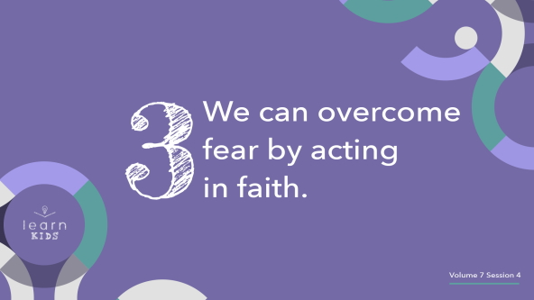

I’m thinking about the heavy object that I needed lots of help to move. It represents our fears, right? What would be something that could lift heavy things with no problem? *(Allow responses.)* Those are awesome answers! When I think about that question, a crane comes to mind. When they are building a tall building, they use a crane that can lift thousands of pounds of building materials without any problem.

God gives us something extra we can use when it comes to dealing with our fear. It’s called faith. Just like a crane could easily move this object out of the way, faith helps move our fears out of the way. Faith means our trust in God is bigger than what we’re afraid of. Jacob was so scared about going to Egypt, remember? Then, God told Jacob that he had no reason to fear because He would keep Jacob safe. That’s a great thing to hear from God, but how could Jacob know that it was true? By acting in faith. When Jacob had the faith to go and do what God had said, he overcame his fears through his faith in God. If Jacob had never used that faith to face moving to Egypt, he would have always had that fear. He never would have overcome it.

Remember, fears aren’t always bad. The fear of a dangerous animal or unsafe situation can help to keep something bad from happening to us. But, when those fears rule our life and keep us from having peace inside, then we need to give the fear to God. This is also a time to ask others to help. God doesn’t mind if we tell our parents or a trusted adult about what we’re afraid of.

**Prayer and Response**

*Consider playing a worship song softly in the background while kids pray.*

|  |
| --- |
| ***You Will Need***   * *Paper strips, one per kid* * *Pencils or pens, one per kid* * *Basket or box*   *No prep needed for this activity.* |

Everyone will face fear at some point in their life. Jacob was an adult, and he still had fears and worries. God wants to help us when we’re afraid. Let’s ask God to help us with any fear that we have.

First, think about or ask God if there is any fear that is keeping you from having peace. Then, I want you to write that fear down on a strip of paper. When everyone has done that, we’ll pray about those fears.

• *Give kids time to respond, and then lead them in prayer.*

**Prayer**

• *Optional: Have the kids repeat phrases of the prayer after you*.

|  |
| --- |
| Dear God, I give this fear to You. I trust You with it. I ask You to give me faith to overcome it and have peace in my heart. Amen. |

Now, let’s show God that we want to get rid of those fears. Drop your fears in the basket to represent that you’re leaving that fear behind you.

* *Pass the basket or have kids bring their slip and place it in the basket.*

**Faith Verse**

Our Faith Verse reminds us that Jesus gives us strength to do anything He calls us to even when we feel afraid. Let’s say our Faith Verse and do the actions together.

• *Play* ***Faith Verse Video****.*

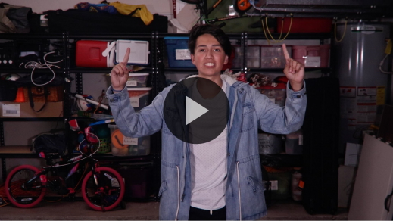

[Philippians 4:13](https://ref.ly/logosref/Bible.Php4.13) (NLT)

For I can do everything through Christ, who gives me strength.

Remember that anytime you’re afraid, you can give your fear to God. He can handle it, and He can show you how to have faith to overcome it.

**Faith Fact**

Before we go to our small groups, let’s say our Faith Fact again. **God helps me when I am afraid.**

• *Show the* ***Faith Fact Slide****.*



God is always with you! He will always help you when you’re afraid or worried. No matter what you face, He can give you the peace in your heart and mind He wants you to have.

• *Dismiss kids to Small Group time or to go home if your group time ends here.*

**Small Group**

**30 Minutes**

*This section can be done in conjunction with the large group or on its own if you do small groups with your kids. During Small Group time, the goal is to connect the kids with the Word of God and to each other. All activities are led by the small group leader.*

**Group Connection**

**What’s Your Fear?**

|  |
| --- |
| ***You Will Need***   * ***Small Group Group Connection Page***   ***Getting Ready***   * *Print the* ***Small Group Group Connection Page****, one per group.* |

Most people have a list of different kinds of things they’re afraid of. What kinds of fears do you see here? *(Allow responses.)*

• *Show the* ***Group Connection Page*** *to the group.*

Some fears, like being cautious around strangers, aren’t bad fears to have. Some fears help us make wise decisions, but others make us worry all the time. God doesn’t want us to live in constant fear. Sometimes it can help us to name the fears we face and then state what God does to help give us peace.

Let’s each share the fears we have and tell how we can trust God with them. You can choose something from this page or one of your own. Here’s an example: “I am sometimes scared of getting a shot at the doctor’s office, but I know that God is my protector and can keep me safe. Even if the shot hurts, God is still good. He will be with me.”

• *Lead by sharing a fear that you have.*

• *Go around the group and have each kid share.*

Thanks for sharing. We all have different kinds of fears, but God helps us when we’re afraid. I’m so thankful for that.

**Learn about It**

|  |
| --- |
| ***You Will Need***   * *Bibles for kids in your group to share*   *No prep needed for this activity.* |

**Scripture Search:** [**Psalm 34:4–5**](https://ref.ly/logosref/Bible.Ps34.4-5)**;** [**Psalm 91:4–5**](https://ref.ly/logosref/Bible.Ps91.4-5)**;** [**Philippians 4:6–7**](https://ref.ly/logosref/Bible.Php4.6-7)**;** [**James 1:2–3**](https://ref.ly/logosref/Bible.Jas1.2-3)

Let’s dig deeper into God’s Word and see what else He has to say about overcoming our fears. As we find and read each of these verses, let’s consider: What does this Scripture mean for our life today?

• *Give each kid a Bible and search for one or more of the Scriptures as a group together (as time allows). When everyone has found the Scripture, have one of the kids read it. Then, answer the questions about it.*

• *Pair kids who need additional help with older kids or start simple and look up the session’s Bible story Scripture:* [*Genesis 42:1–4*](https://ref.ly/logosref/Bible.Ge42.1-4)*;* [*45:3–9*](https://ref.ly/logosref/Bible.Ge45.3-9)*,* [*16–18*](https://ref.ly/logosref/Bible.Ge45.16-18)*;* [*46:1–5*](https://ref.ly/logosref/Bible.Ge46.1-5)*. Kids will get better at finding Scriptures the more they practice.*

• *Optional: Make this a competition to see who can find the Scripture first.*

**Bible Reading Tip**

God’s Word is so good. The Bible says that we should keep God’s Word in our mind every day. One way we can do that is by memorizing different parts of the Bible. Learning our Faith Verse is an example of that. When we memorize a verse that’s encouraging to us, we can think about it or say it aloud any time we need to, which keeps God’s Word always in our mind.

**Challenge**

Here’s a challenge for you. Choose a Bible verse that sticks out to you. Pick one that you think would be helpful to know and try your best to memorize it. Then, practice it with someone new every day so that you can share God’s Word with others.

If you struggle with a lot of fear, choose verses like [Philippians 4:6–7](https://ref.ly/logosref/Bible.Php4.6-7) that talk about how God gives us peace in our heart and mind. Whenever you’re feeling afraid, quote those verses to remind yourself of God’s truth. It will help you remember that God helps you when you’re afraid.

**Faith Fact**

God’s Word helps bring peace to us because it reminds us of how amazing God is. He is always ready to help us, which makes me think of our Faith Fact. **God helps me when I am afraid.** Say it with me. **God helps me when I am afraid.**

**Group Discussion**

*Feel free to use all or just a few questions as a jumping-off place for good discussion. Questions marked with * are designed for more conversation. Adjust the questions based on the age or maturity of your group. Typically, older kids will be able to dive a little deeper than younger ones.*

**Questions**

• *If small group activities are not immediately following large group time, you may want to read the Bible story passage before this discussion.*

Who was Jacob afraid of losing? Why?

Where was Jacob afraid to go to?

Why do you think Jacob struggled with the fears he did?

What stuck out to you the most about this Bible story?

* What are some reasons that people are afraid of things?

Are fears always bad? Why or why not?

What kinds of fears do people have?

* What should we do with big fears that make us worry all the time?

* How do we overcome fears?

How would your life be different if you always trusted that God helps you when you’re afraid?

**Prayer Requests**

*Finish group discussion by sharing prayer requests and praise reports. Keep track of your small group’s prayer requests and review them each time you meet.*

**Prayer**

*Have kids pray for each other’s prayer requests.*

**Faith Verse Review**

|  |
| --- |
| ***You Will Need***   * *Ball*   *No prep needed for this activity.* |

Our Faith Verse is [Philippians 4:13](https://ref.ly/logosref/Bible.Php4.13). This verse reminds us that God helps us have strength to make it through situations when we feel afraid. Let’s review it now.

• *Show* ***Faith Verse Video****.*



[Philippians 4:13](https://ref.ly/logosref/Bible.Php4.13) (NLT)

For I can do everything through Christ, who gives me strength.

In a time when you feel afraid, remember that God is with you and will help you through every problem you face. Let’s review our Faith Verse as a group a few more times. Try to memorize it as best as you can because you will need to know it for the Faith Verse game.

• *Say the verse as a group a couple times.*

**Faith Verse Fun**

**Toss Across**

Let’s test our memory and our accuracy by playing Toss Across. Here’s how it works. Whoever starts with the ball will say the first word of the verse. Then, they’ll toss the ball across the circle to another friend who will say the next word. We’ll keep tossing the ball around until we’ve said the full Faith Verse.

• *Take turns reciting words of the Faith Verse by throwing a ball around a circle. Consider racing for a time record.*

Great job! This verse is a really good one to know because it reminds us that God will give us strength when we’re worried or afraid.

**Activity Page**

**Maze**

|  |
| --- |
| ***You Will Need***   * ***Small Group Activity Page****, one per kid* * ***Activity Page Answer Page*** * *Pens or pencils, one per kid*   ***Getting Ready***   * *Print copies of the* ***Small Group Activity Page****, one per kid.* * *Print one* ***Activity Page Answer Page*** *to show the answer to the maze.* |

Our Bible story explained that Jacob had to travel a long way to see Joseph again. It was probably a hard trip for him to make.

• *Give a copy of the* ***Small Group Activity Page*** *and a pencil to each kid.*

Solve this maze to help Jacob reach Egypt and see Joseph again. What do you think Jacob did when he got there? *(Allow responses.)*

• *Optional: Read* [*Genesis 46:28–30*](https://ref.ly/logosref/Bible.Ge46.28-30)*.*

• *Use the* ***Answer Page*** *as needed.*

**Dismissal**

Remember that whenever you are afraid, God is with you. He knows all the different fears that each one of us face. He is strong and powerful enough to handle all of them, and He helps us have the faith to overcome them. Let’s pray.

**Prayer**

|  |
| --- |
| *Dear God, help us to see that You are close to us when we’re afraid. Help us to trust You with every fear that we have. Help us to be brave in our faith to overcome the fear so that we can have the peace You want for us. Amen.* |

**Faith Fact Recap**

• *Show the* ***Faith Fact Slide****.*



Something I want you to remember from our time today is our Faith Fact. Let’s say it together one more time. **God helps me when I am afraid.** I’m so glad that we could learn this powerful truth together today. I can’t wait to see you next time.

• *Send home the* ***Small Group Activity Page.***

• *Remind parents that there are* ***Family Devotions*** *available on the app to do with their kid.*

• *Tell everyone the date and time for the next session*.